Post lab

1) module sipo(clk,clear, si, po);

input clk, si,clear;

output [3:0] po;

reg [3:0] tmp;

reg [3:0] po;

always @(posedge clk)

begin

if (clear)

tmp <= 4'b0000;

else

tmp <= tmp << 1;

tmp[0] <= si;

po = tmp;

end

endmodule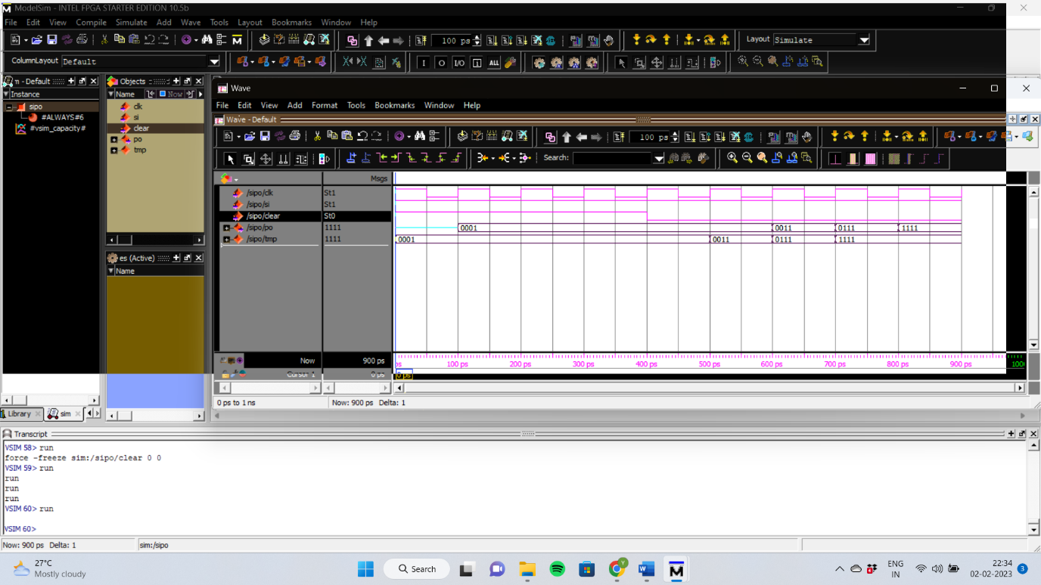

2) module pipo(clk,clear, pi, po);

input clk,clear;

input [3:0]pi;

output [3:0] po;

reg [3:0] tmp;

reg [3:0] po;

always @(posedge clk)

begin

if (clear)

tmp <= 4'b0000;

else

tmp <= tmp << 1;

tmp <= pi;

po = tmp;

end

endmodule